Module 08 – Scheduling Problem

Exploratory Data Analysis

*In this section, you should perform some data analysis on the data provided to you. Please format your findings in a visually pleasing way and please be sure to include these cuts:*

* *Make a table (similar to the textbook example) showing the temporary agency data*
* *Run summary statistics on the sample of Full-Time employee salaries. Record the Mean to use in our model*
* *Make a line graph showing foot traffic over the next 12 months. Call out any seasonality or trend you may see.*

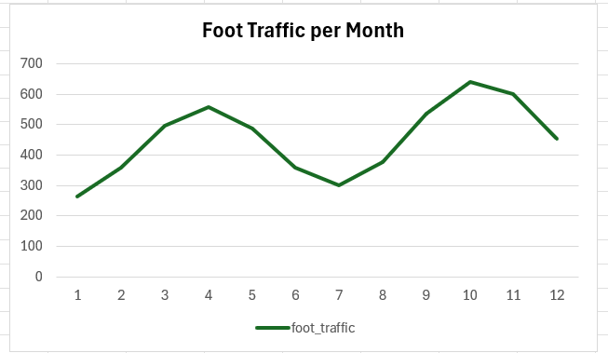

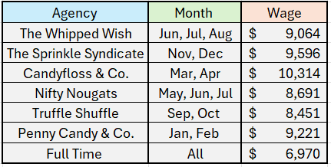

Model Formulation

*Write the formulation of the model into here prior to implementing it in your Excel model. Be explicit with the definition of the decision variables, objective function, and constraints.*

X1​=# of schedules hired from The Whipped Wish

X2​=# of schedules hired from The Sprinkle Syndicate

X3=# of schedules hired from Candyfloss & Co.

X4​=# of schedules hired from Nifty Nougats

X5=# of schedules hired from Truffle Shuffle

​X6=# of schedules hired from Penny Candy & Co.

​X7=# of full-time workers hired​

MIN = 27,192X1 ​+ 19,192X2​ + 20,628X3​ + 26,073X4​ + 16,902X5​ +18,442X6 ​+ 83,640X7​

Jan: X6 + X7 >= 263

Feb: X6 + X7 >= 360

Mar: X3 + X7 >= 497

Apr:  X5 + X7 >= 556

May: X4 + X7 >= 488

Jun: X1 + X4 + X7 >= 360

Jul: X1 + X2 + X4 + X7 >= 300

Aug: X1 + X7 >= 378

Sep: X7 >= 641

Oct: X7 >= 641

Nov: X3 + X7 >= 599

Dec: X2 + X3 + X7 >= 454

Model Optimized for Min Costs to Cover Store Foot Traffic

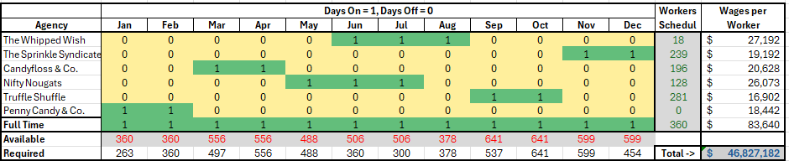

The model is recommending how many workers to have on staff, for each company, and on which month, in order to keep the total cost for all workers at $46,827,182.

Model with Stipulation

*Please copy the tab of your original model before continuing with the next part to avoid messing up your original solution.*

1. *Unfortunately, leadership wishes to have a reduction in workforce. While the monthly salary for full time employees is cheaper than temporary workers, there are other costs associated with full time employees that they wish to cut. Add a constraint to your model that takes your first model’s recommended number of full-time employees and constrains it to be only 80% of it. Add a text explanation of the change in the optimal value as well as any other changes noticed between the models.*

New constraint = X7 <= 0.8 \* 360 = 288

The model becomes unfeasible since there isn’t a company that covers February (360 req.), so with only 288 full-time workers, February can't be covered.

Full-time workers can’t go below 360 without either lowering the number of workers required for February, or changing the months that certain companies have availability.

1. *Alternatively, leadership would like to see what the average monthly salary for an employee would need to be to cut out all temporary workers as they believe that will help negate excess spending. Convert your model (or do the math out yourself) to figure out what monthly salary you would need to pay your full-time employees to only have full-time workers at the same optimal cost as the original model.*

Max employees demanded in a given month = 641

641 \* full-time annual salary = $46,827,182 🡪 $46,827,182/641 = $73,041 per year/12 = $6,087 per month (12.6% below the current monthly employee salary of $6,970)

1. *Considering trends and seasonality of this business, what would you recommend leadership to do? Feel free to play with the model and recommend something else.*

Reduce, but not eliminate, the amount of part-time workers, therefore increasing full-time workers. And increase the amount of workers for the cheaper companies such as Truffle Shuffle and The Sprinkle Syndicate.